# Medical Image Computing 2016-2017

# Question 1

## Part a

Histogram equalisation increases the global contrast of the image. I don’t think this is assessable.

# Question 2

## Part a

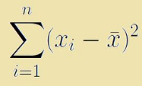

* SAD is more robust to outliers since SSD will take the square of any error, and the value of the error squared will be much farther from the true value than the absolute value of the error.

From practice question model answers:

* (a): Normalised Mutual Information. Ventricles are dark in both images, but grey matter is inverted, so there is no linear relationship between intensities.
* (b): NMI, possibly Correlation Coefficient. Darker and brighter regions seem to correspond to some extent. NMI might be the better choice.
* (c): Correlation Coefficient. Linear contrast change between the images, so there
* is a linear relationship between intensities.

## Part b

I don’t think feature-based image registration was covered this year.

Image registration as an iterative process:

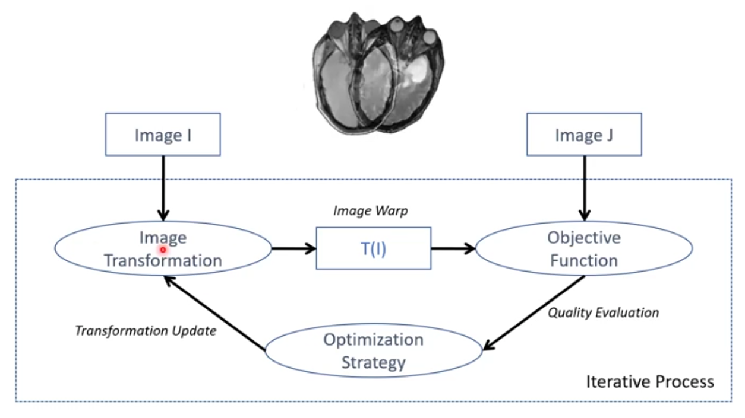

1. Perform an image transformation onto Image I
2. Compute the objective function
3. Feed this to the optimisation strategy
4. Perform a transfomation update until done

We can alleviate the issues of capture range, initialisation, and local optima is to use **multi-scale hierarchical** registration. We can successively increase the degrees of freedom using Gaussian image pyramids.

## Part c

This is a multi-modal registration problem. For intensity-based registration, you would use mutual information as your dissimilarity metric. We would use a 3D rigid transformation model (6 DOF) since both MR and CT imaging produce 3D images which may be misaligned, but of similar scale.

# Question 3

## Part a

We can apply unsupervised learning to do anomaly detection, for example via clustering (on the image-level) or autoencoders (on the pixel-level).

* **Classification:** classify the progression of eye disease by grade using a CNN with annotated images.
* **Regression:** predict the age of a patient from an MRI scan using a CNN with annotated images.

## Part b

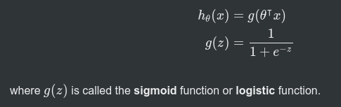

Where x is the training data, and theta are the parameters to the model.

We can use logistic regression for these problems by using non-linear decision boundaries. We do this by using higher-order polynomial terms For (a) you want something including x_1^2 and x_2^2.

## Part c

I don’t think Naïve Bayes is assessed anymore.